# Dental Floss and Epistemology

The jury is in! The weight of science has been thrown down on yet another study and now we can all safely rest at night. We can all look our dentists right in the eye (or should it be mouth?) when he asks have we flossed and we can say “[Nope, science says we don’t need to!](http://www.health.harvard.edu/blog/tossing-flossing-2016081710196)”

But it is worth asking just why is everyone sure that this is the right thing to do? Haven’t scientific studies been wrong before? Wasn’t there science behind the recommendation to floss? Just how long will it be until a new study overturns the old one? And is it really true flossing has no benefit (outside the profits for the manufacturers)?

Let me take a stab at addressing the first questions immediately and deferring the benefits of flossing until later.

Perhaps the best place to start is by discussing a thought-provoking article entitled *Scientific Regress* from the May 2016 edition of *First Things*. In that piece, William A. Wilson, a software engineer, gives a nice summary and analysis of the state of modern science. Not the state of its discoveries or knowledge base but the state of what it knows about itself and how it knows what it knows to be true. In other words, Wilson gives a meta-analysis of the state of the scientific method and its corresponding epistemology.

Of course, the central notion to any of the scientific enterprises is the idea that what happens in the hear-and-now is applicable to the there-and-then. Without that basic premise, science would nothing more than a set of anecdotes starting with “I swear that I witnessed…”. It is vital that scientific claims are verifiable. Repeating an experiment, which should be done often, should give rise to the same results and the same conclusions. After all, that is the underlying mechanism by which scientific discoveries become technological breakthroughs. Think what would happen if the original experiment that established the proof-of-concept of the solid state transistor were a one-off. Goodbye cellphone, household computers, the internet, inexpensive televisions and radios, and hosts of other modern-day goodies.

And yet, the picture that Wilson paints about modern scientific explorations shows a system that is seriously flawed. He cites the efforts of the Open Science Collaboration (OSC) that tried to replicate 100 published psychology experiments taken from three of the most prestigious journals of the field. (I’ll have occasion to revisit the notion of prestigious a bit later).

According to the article, OSC found that, in 65 cases, they could not replicate the positive results that were reported in these so-called scientific studies. In addition, they found that a bulk of the remaining 35 cases were marginal in that their positive results were not nearly as statistically significant as first claimed.

And while other disciplines are not plagued with irreproducibility of this magnitude, there are still many cases where the results of given experiments can’t be corroborated by other groups.

So what is behind this lack of reproducibility? According to Wilson, the answer lies in one of two areas.

First is the possibility that there is a set of confounding variables in the experiment – conditions that need to be controlled but are not recognized as such. For example, if temperature were important in a study of perceptual psychology but was never imagined to be so then the study authors may not report the temperature and therefore their experiment would not be exactly reproduced. This explanation would be one-part blessing and one-part curse as the presence of such an effect would reveal layers of reality unknown to this point but would make it hard to ever replicate an experiment. Of course, this kind of thing happens, but to occur with a frequency high enough to explain the OSC results strains credulity.

The second, and more likely reason, is that the original conclusions of the study are simply wrong. Three possibilities here; what I will call: statistical false alarms, group think (what [Bacon & Bacon](http://aristotle2digital.blogwyrm.com/?p=233) call either Authority or Idols of the Theater), and downright fakery.

The most assuring one is the statistical false alarms. There is a nice Bayesian argument that Wilson attributes to ‘’’ that argues that many scientific studies must be wrong. The argument goes something like this. Suppose you have a gem detector that has an accuracy of 95%, which means that if you know it is hovering over a gem it will alert the user positively most of the time and, conversely, if it is hovering over a piece of glass it will not react most of the time. Armed with this good detector, you then journey out to a field filed with pieces of glass with an occasional gem dropped into the mix. Since you don’t know which is which and the population of the gems within the greater population of useless baubles is only small, the actual probability of getting a false alarm can be very high. Details on this kind of argument can be found in an earlier column on Bayesian analysis. Now consider the gem or useless bauble as a positive scientific discovery or null result, respectively, and the usual machinery of statistical inference to a 95% confidence as the gem detector and you are left to conclude that the possibilities of new discoveries reported in a study bearing up under scrutiny are rather low.

But isn’t this how science feels its way forward? Isn’t this how we progress? The answer to these queries is actually a guarded yes. Our tolerance to being wrong shouldn’t blind us to wrong-doing. Some of that wrong-doing is subtle and often due to the perverse incentives that we, as a society, has heaped on the scientific enterprise.

Consider the possibility of group think in research. Positive results receive huge press releases, the promise of fame and fortune, and a huge boost to the intellectual pride. Articles based on ‘breakthroughs’ aim for large impact factors and promise tenured positions and speaking circuits. In Negative results, often far more important in the scheme of things, are judged to be not worth reporting. This despite the fact that as Edison famously said about ‘failure’:

<Negative results are just what I want. They’re just as valuable to me as positive results. I can never find the thing that does the job best until I find ones that don’t.>

Far worse than this institutionalized self-delusion is the case of outright fakery. As the recent spate of scandals indicate, it is all too common – and not just in the soft sciences. It is standard to see complaints of plagiarism in the physical sciences (especially from India and China). Reports abound of authors gaming of the peer-review system by creating aliases for themselves that give them the ability to vet their own articles.

Far worse than any of these offenses is the downright cheating that is becoming all-too common. There have been amazing examples of the wool being pulled over the collective eyes of peer review. One of my favorites is narrated in the book [*Plastic Fantastic*](https://en.wikipedia.org/wiki/Plastic_Fantastic), by Eugenie Samuel, which narrates the flummery of one [Jans Hendrik Schön](https://en.wikipedia.org/wiki/Sch%C3%B6n_scandal) a German physicist who became a famous figure in condensed matter physics with his breakthrough results. He was given two prestigious awards and published in the prestigious journals of *Science* and *Nature* (there is that adjective again) before the house of cards came tumbling down when it was determine that he hoodwinked ‘smart’ people for years with amazing but made-up results. Papers were retracted from many prestigious journals, proving that prestige is more perception than anything else. Schön’s story is hardly an isolated case and some simple searches can find lots of examples of academic foul play. There have always been cheats in science but the current system encourages it to a degree never seen before – after all there is big money in and power in science.

So what to do when a new study comes out? For the most part, take it with a grain of salt, especially if it is predominantly populated by statistical analysis using hypothesis testing with no clear physical mechanism to explain the results. As for flossing – well I will continue to do it (even though I would love to stop). The reason being that I have actually experimented with flossing and not flossing and have found that my mouth feels better, I breathe better, and my teeth have fewer complaints (pain, cavities, etc.) for the dentist. I suspect that the reason that my results are in conflict with this study is that all of human kind can’t be summarized by a ‘representative sample’ and that something about me, whether it is nature or nurture, sets into one of those small populations that Bayesian analysis warns us about.

## Vicious Cycle

Often in macroeconomics analysis we hear about favorable and unfavorable business cycles, of the ebbing and flowing of macroeconomic forces of aggregate supply and demand that can sale a fleet of businesses into new waters teeming with fish or pitch them onto a reef. But there is another and more interesting business cycle which some recent experiences have put firmly in my thought.

The stage for my experiences can be set with one simply phrase – back to school shopping. Like millions of parents across the United States, I found myself in the position of hauling one of my kids and a not-insignificant subset of his position some 350 miles north to college. I have made this particular trip many times, laden with pounds and pounds of teenage positions. But what made this trip particularly interesting was it was the first time one of mine had housing in an unfurnished apartment, which was being shared between him and 3 other young men. This routine return-to-college trip suddenly transformed into something akin to a permanent moving to a new city.

Since my vehicle was the family car and not a rented U-Haul, the necessities of furnishing a new apartment had to be done once we had arrived and that meant purchasing lots of furniture in a short time from stores that I don’t normally or never had patronized before. And that is where the lesson really begins.

Looking for bargains (who doesn’t) and being in unfamiliar territory led us to visit a chain that had once been mighty in days gone by and was now transformed into something more akin to a bottom-feeder. I won’t mention the name for the very reason that doing so contributes the very ‘business cycle’ that this column is about.

This store, a mere shadow of what it once was during its former glory days, offered nice products, a bit on the cheap side, but nice. That said, neither the quality of the goods nor the quality of the shopping experience could really compare to its higher end competitors. Nonetheless, we found some suitable choices at prices we could live with and so the deals were struck, trunks were loaded and so on.

After having delivered and installed these items in our son’s room, we got into talking with the parents of the other boys, who, like us, were trying to furnish the apartment with as little cash outlay as possible – paying tuition tends to do that to a parent. We recommend the chain we had just visited and off the others went to give it a look.

Hours passed before they returned bearing goods from one of the competitors. When we asked what they thought about the store we recommended we got an interesting answer. It seems that the other parents had gone and had actually seen a set of table and chairs that would work for the shared kitchen at an agreeable price. What had stopped the deal from happening is that they wished to talk to someone about the goods and, after waiting 20 minutes, they had decided that the customer service was terrible and they took their dollars somewhere else.

As they were narrating their experience, I realized that when we were shopping in that store I hadn’t really seen any employees around. The store, for the most part, was devoid of employees. A few were at the registers, a few more at the snack bar, and I saw a manager moving to and fro keeping an eye on things. But I didn’t see employees circling different areas (e.g. electronics, apparel, etc.). There just wasn’t that many people supporting the day-to-day operations.

As I reflected on this realization, I found myself led to two different conclusions.

First, it makes perfect sense that the number of employees for a store such as I described earlier should be minimal. An institution trying to hang on to the low end of the market share can’t cut goods or store space. The only thing they can cut is people cost. They need to offer less in the way of services in order to keep costs and prices down and, in doing so, stay competitive.

Second, the necessity of cutting personnel costs drives customers and, more importantly, dollars away. As the shopping experience falls so does the traffic into the store and the probability of moving goods.

And so it is easy to see how a viscous circle can form that drives businesses out of business. It starts when a business stops growing, either due to management missteps or changing tastes or new technology, and begins to lose customers. As the cash flow beings to dwindle, the business need to cut back on goods and services, which usually results in an accelerated loss of customers, which in turn accelerates the descoping.



This negative feedback loop has only two ends. Either the company finds just the right combination of new goods and services to offer or it goes under. And it seems that the later outcome is more usual compared with the former. It takes a lot of hard work and luck for a business to reinvent itself once public perception has gone the other way and both of those require that the business stay afloat while the reinvention takes place – and that means capitol.

Capitol to continue the supply chain so that goods stay on the shelf. Capitol to keep employees working the business and keeping the customer service high. Capitol to create and air advertisements that hopefully change the consumer attitude towards the business. And if that capitol isn’t available, the viscous cycle will just pull a business down.

Indeed, there is a lot of truth in that old saying that it takes money to make money.

# New Universe – Part 2: The Supporting Books

This week’s column covers the smaller-run books in the *New Universe*. Originally conceived with the hope that each would become a regular, ongoing, and essential independent title, these series underwent a marked change in tone and direction about 3/4 of the way through their first year. At this turning point, it seems clear that the Marvel editorial staff had decided to pivot the entire *New Universe* line to a more integrated set of books that would serve more as an extended, interlocking set of graphic novels more than anything else.

The specific series that made it only their first anniversary were *Kickers Inc.*, *Mark Hazzard: Merc*, *Spitfire and the Troublemakers,* and *Nightmask*. As will be discussed in detail below, each of these series was mostly independent and oblivious of the rest of the NU when it was launched. At the turning point, all four became grimmer and three of them (all but *Nightmask*) became supporting vignettes for escalating tensions between the United States and Russia. In addition, the lead characters would be spun off into the larger *The Pitt* and *The War* storylines that would come later.

## Kickers Inc. (12 issues)

The first of the short-lived books and definitely the weakest in terms of premise and overall storyline was *Kickers Inc.,* which, sported 8 different writers over its 12-issue run.

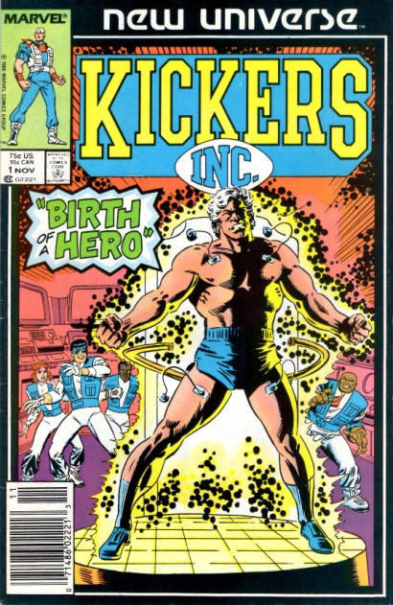

Created by Tom DeFalco and Ron Frenze, the plot line followed the star quarterback of the New York Smashers, Jack Magniconti, who acquires super-human speed, endurance, and strength. The original explanation offered, at least to the characters within the framework, is that Jack’s brother has exposed the star athlete to a state-of-the-art performance enhancing substance, although later Jack’s power is attributed to the White Event.

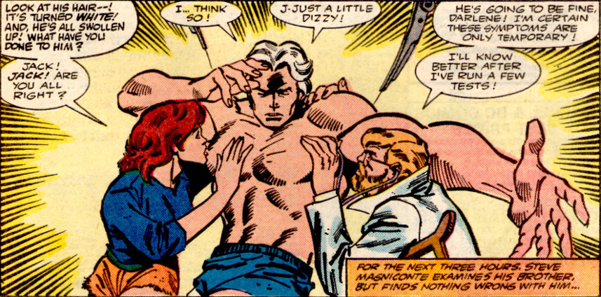

The series never got its legs underneath it and the reader was left wondering what there was to care about and how it had anything to do with the world outside his window. After his metamorphosis, Magniconti founds a non-profit aid group comprised of himself, his wife, and three of his teammates. Their aim was to help people who had nowhere else to turn. This idea never panned out and the trajectory of the story ping-ponged between the group, Jack’s guilt over having an unfair advantage on the gridiron, and a ludicrous situation where the owner of the team, a vindictive harpy, plays Jack in tennis match to decide the fate of the team. Not to mention the ludicrous notion that a set of professional athletes would have the time and skill to run around the world confronting bad guys risking their football careers.

*Kickers Inc.* finally settled in on a much grimmer plot where the footballers are played by the CIA into doing their dirty work.

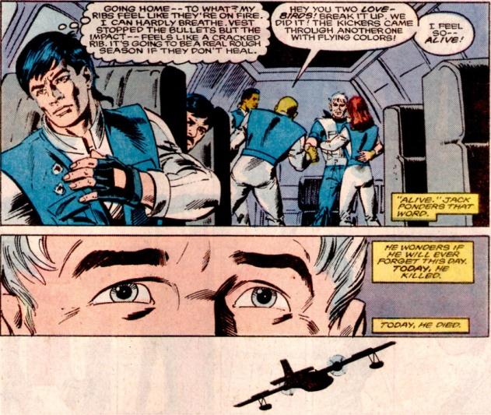

These events later set the stage for Captain Magniconti being at the forefront of the paranormal soldiers who were drafted to fight in the World War III events that unfold at the end of the NU line.

## Mark Hazzard: Merc (12 issues & 1 annual)

Initially conceived and written by Peter David, *Mark Hazzard: Merc* was the odd-man out of all of the NU books. There was no tie-in with the White Event and the initial stories, while interesting at times, offered nothing in terms of the science fiction theme that Shooter claimed he wanted a central to the NU.

Instead, David’s plots focused on the attempts to balance work and home life of the titular character.



This approach was certainly consistent with the ‘world outside your window’ tagline but not with anything else NU had to offer. David left after only writing four issues and was subsequently replaced by Doug Murray, who stayed at the helm for the remainder. At times, his depiction of armed conflict was downright silly,



but eventually the series started to deal honestly with the costs of war. The art was far more of an issue and, by my count, there were 11 different illustrators used in 13 different tales.

The book also features one of the most unusual moves ever published – the death of the main character before the end of the series. In the annual published between issues 11 and 12, a mortally wounded Mark Hazzard is taken off life support and allowed to die peacefully in his sleep

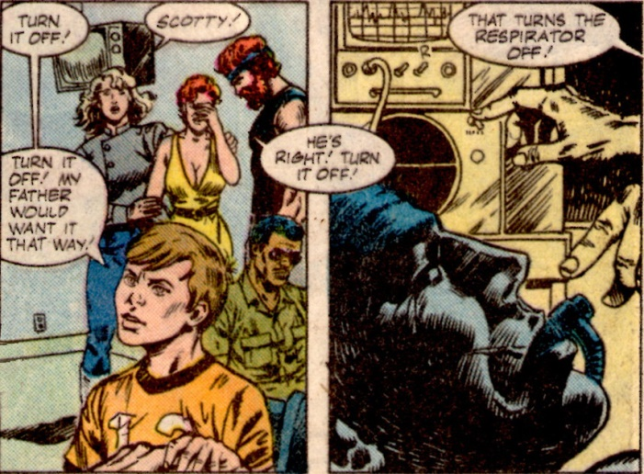

The final issue, entitled *Merc*, followed the secondary characters and their adventures in the Middle East and Near East Asia that had appeared in the latter half of the series. The only lasting feature of the book was the introduction of the Afghan conflict as a central plot point that would be knitted into the World War III scenario.

## Spitfire and the Troublemakers (13 issues)

Elliot R. Brown and Jack Morelli conceived of this series but, oddly enough, contributed only to the first issue; a sign of the chaos that swirled around the launch of the NU.



According to the [Wikipedia entry](https://en.wikipedia.org/wiki/Spitfire_(New_Universe)), Brown is on record as saying:

<It was more than Iron Girl, it was a different technological attitude, more reality-based. Iron Man was not unreal, but Iron Man as a concept did too much. Even in the 1980s, the suit was so smart, it could have gone off and had its own adventures. I tried to do something that was more of a garbage can with legs and a good brain in it, something more mechanical.>

about the original concept for the series. Unfortunately, Gerry Conway, who wrote the first 6 issues, must not have gotten the memo as his plots really couldn’t have been more farcical.

As mentioned in the last post, Conway’s stories covered the adventures of the far too brilliant female MIT professor by the name of Jenny Swensen (nickname Spitfire by her father) and her four favorite students who were already accomplished engineers and scientists and mechanics and truck drivers and so on (sure, every college student at MIT has a commercial driver’s license and knows how to handle a big rig – it’s a requirement in the application).

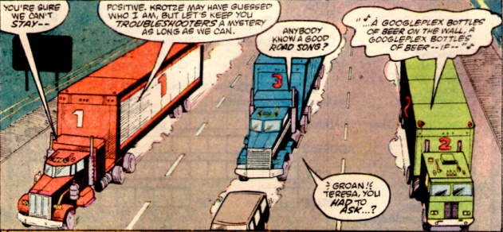

This series also had no direct tie-in with the White Event and its initial place in the NU was unclear. The basic premise was the Swensen’s father had invented an exoskeleton (called M.A.X.) while in the employ of an evil business man. This crooked captain of industry, Fritz Kroetze by name, subsequently killed Papa Swensen in order to lay claim to armor that he paid for in the first place. Has nobody heard of contract law? Also why are all technological geniuses such poor judges of character?

Jenny, judging herself morally entitled to her father’s work rather than the man who bore the development cost, steals the armor and off she goes. It is true that she struggles with the ethics of this choice and she gets tossed in jail for some of her actions in the suit, but that is the extent of the ‘world outside your window’ motif. Mostly, this phase of the book could be best thought of in terms of the kind of super-science found in Spy Kids (without as much humor and charm).

Neither Swensen nor her cadre of young groupies ever seemed bound by the constraints normal people suffer. They never seemed to be stumped for ideas, or to need sleep, or make mistakes. With that much drive and know-how, they could have started their own tech-giant and simply bought out the ‘bad guy’ rather than resorting to theft. Alternatively, they could have even invented a better suit and had a real mechanical donnybrook with the original. Not that this latter scenario would have been realistic but at least it would have been consistent and entertaining.

Thankfully, when Conway’s run ended, Cary Bates took the book in a whole different direction. Along the way Jenny and her gang had crossed paths with a terrorist who they defeated and humiliated. He returns with a vengeance and kills off most of the Troublemakers, showing that knowledge and cunning are two different things.

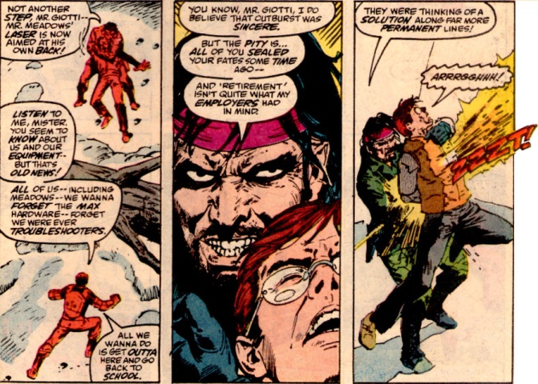

With her reputation in tatters and her band of merry kids dead or discourages, Swensen is easily pressed into CIA service and is given a better M.A.X. armor (see I knew that someone other than her father could do it). Her subsequent adventures overlap with the Afghanistan conflict, further advancing the imminent World War III scenario. In the final stage of here development, NU editors decide that Swensen is more interesting when she is made of metal rather than being inside of a metal suit. Exposure to the bizarre substances from The Pitt, slowly transform her into a female analog of the X-Men character Colossus and she becomes the reoccurring character Chrome in the last third of the *D.P. 7* series.

## Nightmask (12 issues)

The final entry in the short-and-not-sweet group of NU publications if *Nightmask*. Created by Archie Goodwin, the premise revolves around a young man named Keith Remsen who was acquired the ability to enter other people’s dreams.

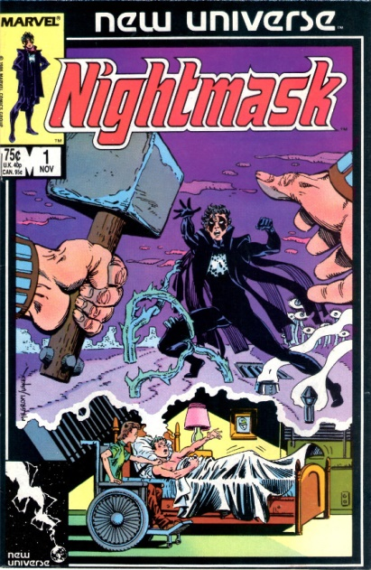

In the first issue, Keith is thrown into a coma as a result of an explosion design to kill his parents and which, incidentally, turned his sister into a paraplegic. Though not clearly tied to the White Event, Keith awakens from his coma after its occurrence with the ability to project his consciousness into the mind of a dreamer.

The idea of dream walking had been around for a long time but mostly in the realm of movies (e.g. [Dreamscape](https://en.wikipedia.org/wiki/Dreamscape_(1984_film))). One notable comics exception is the first Doctor Strange story ever written in which the Master of the Mystic Arts journeys into the dreams of a haunted sleeper only to encounter Nightmare. However, all these stories seemed a bit hollow as they seemed to lack real-world consequences. It would take another 3 decades or so until the movie Inception would go on to show us just how compelling the whole idea could be.

Unfortunately, like the other dream-based tales of its time, Nightmask also failed to capture the cool aspect of shared visions. Instead many of the earlier stories centered on Remsen getting some kind of revenge on his parent’s assassin (interestingly the final revenge story had to wait 20 years for publication in the *Untold Tales of the New Universe*). Eventually, Goodwin would drop away from the stories and Roy Thomas ended up writing the series until its cancellation. These later stories were no more interesting and the publication run closed on a voodoo storyline that was boring at best. In addition to the lackluster plots, the graphics left much to be desired. Although there is a clear homage to the Ditko style used on Doctor Strange

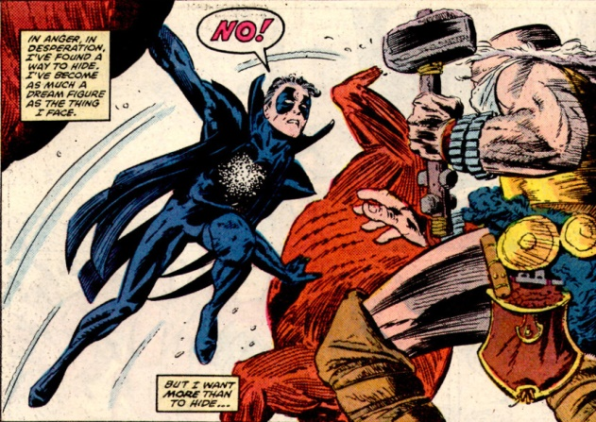

the art on most of the books seemed rushed – a problem that plagued the entire NU line.

The Nightmask character outlived his book and become a pivotal figure in the World War III scenario with Keith Remsen working as an Army officer whose prime responsibility is to judge the fitness for service of other paranormals who have been drafted. His one wrong call on an unbalanced recruit haunts him as the man ends up becoming a serial killer who literally assassinates his victims by blowing up them and himself. Keith finally feels that the only way to set things right is to kill the assassin; an action that drives him mad with guilt.

Next month, I’ll close out this look at the New Universe by delving into the longer running titles that provided the richer storylines.

## Jvstice

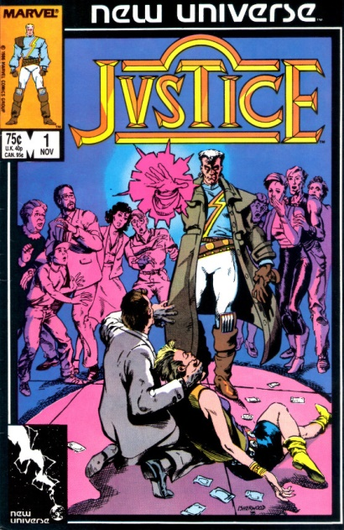



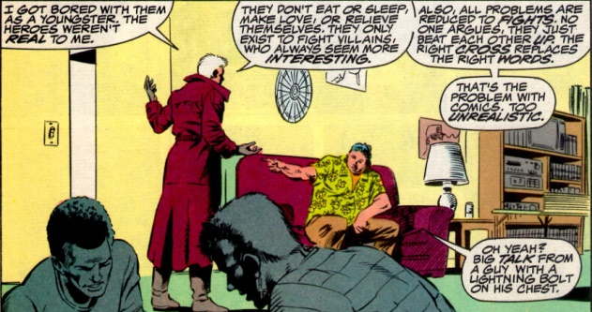

## Psi-Force

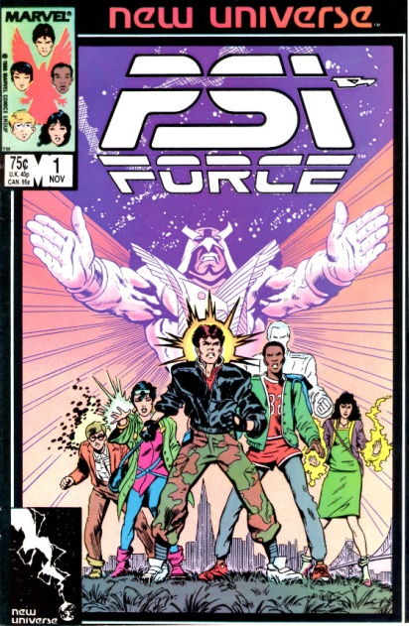

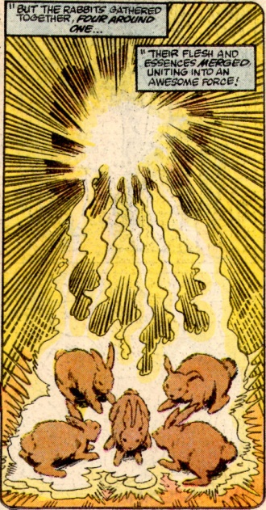



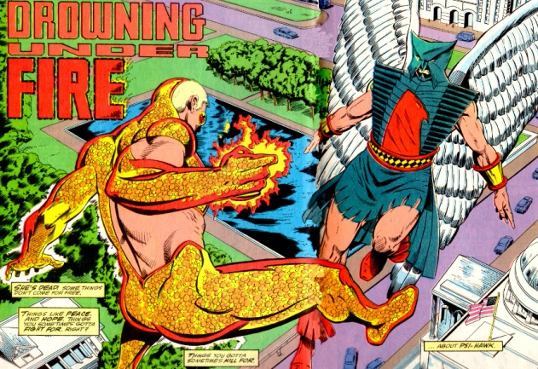

## D.P. 7

Perhaps the most stable of the NU offerings, D.P. 7 followed the lives of various paranormals who had

